Simple query mysql ( Bagian 2 )

1. select * from persediaan_obat;  
   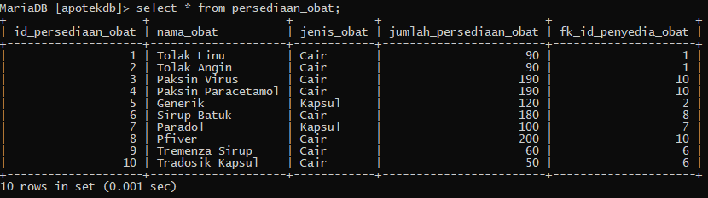
2. select nama_obat, jenis_obat from persediaan_obat;  
   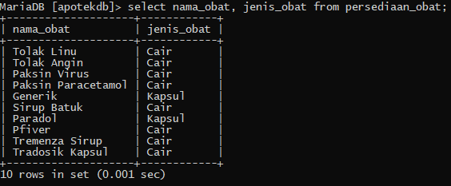
3. select * from persediaan_obat where nama_obat='Sirup Batuk';  
   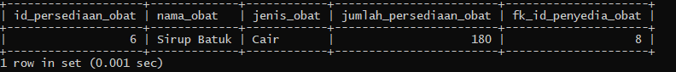
4. select nama_obat from persediaan_obat where nama_obat='Sirup Batuk';  
   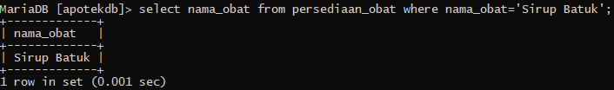
5. select sum(jumlah_persediaan_obat) from persediaan_obat;  
   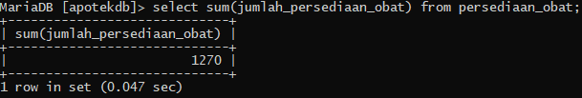
6. select sum(jumlah_persediaan_obat) from persediaan_obat where jenis_obat='Kapsul';  
   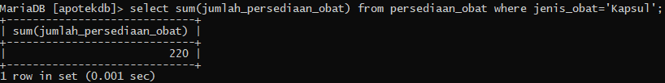
7. select * from penyedia_obat;  
   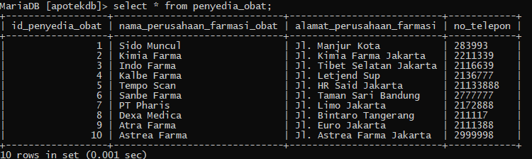
8. select nama_perusahaan_farmasi_obat, alamat_perusahaan_farmasi from penyedia_obat where nama_perusahaan_farmasi_obat like "%Muncul%";  
   
9. select alamat_perusahaan_farmasi from penyedia_obat where alamat_perusahaan_farmasi like "%Jakarta%" group by id_penyedia_obat;  
   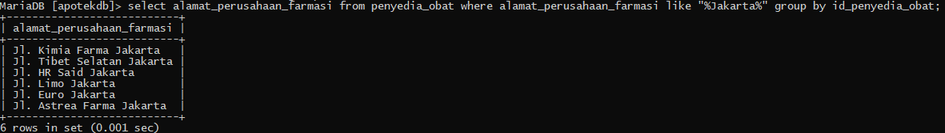
10. select nama_obat, jenis_obat, jumlah_persediaan_obat from persediaan_obat where jumlah_persediaan_obat > 150;  
    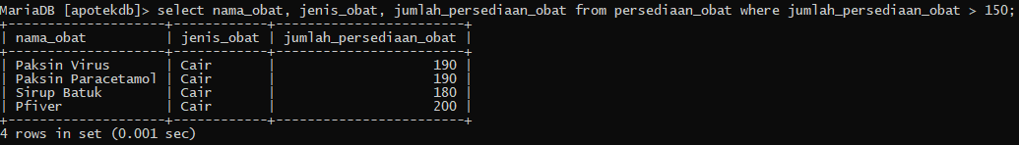
11. select id_persediaan_obat, nama_obat, jenis_obat, jumlah_persediaan_obat from persediaan_obat where jumlah_persediaan_obat <= 50;  
    